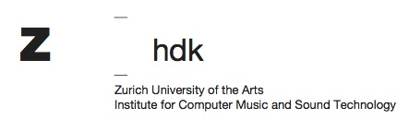

EARS Program at ICST – Application Form 2023

Personal Information

Salutation:

First Name:

Last Name:

Date of Birth (dd.mm.yyyy):

Nationalitiy:

Street, House No.:

Postal code:

City:

Country:

Contact

E-Mail:

Phone (private/mobile):

When did you receive a Master’s degree (year of graduation)?

What was your major subject?

For how many years have you been active as an artist?

What is the planned field/topic of your PhD project?

In which topics do you wish to receive mentoring?

